<insert name> Trail/Network

Appendix 4D: Detailed Design

  - <insert Partner names and/or logos>
  - <insert Date>

<insert name> Trail Network Summary

Project Background
<insert project background>

Site Summary
<insert summary/description of project site>

Breakdown of trails
<insert trail breakdown – types, styles, classification, length>

General Construction Standards
<insert any general construction standards relative to all trails within the network>

<insert name> Trail Network map
<insert map of trail network showing Trail 1, Trail 2, etc, as required>

Trail 1 Design

Trail Description
<insert summary description of the trail

Trail Details
Trail Classification –
Trail Length –
Trail Type – <XC, DH AM, etc>
Trail Style – <technical, flow or other>
Trail Purpose – <ascending/descending, single/dual/multi purpose>
Trail Direction – <single or dual>
Site Gradient (side slope) –
Trail Gradient –
Trail Fall/Gain –
In-Situ Soil Type/s –
Natural features –
Construction Footprint Width –
Finished Trail Tread Width –

Trail Technical and Drainage Features
<insert list of technical trail features and drainage features, proposed trail filter (MTB trails), >

Trail Construction Standards
<insert and specific construction and finishing standards, including vegetation clearing and disposal, fall zone dimensions & treatments, recommended machinery and equipment>

Construction Materials
<insert summary of materials – type, quantity, source (local or imported), etc>

Trail 1 Map
<insert detailed map of the trail alignment, with filters, technical features and drainage marked and labelled to match Construction Table items on next page>
<identify machinery access where required>

Trail 1 Construction Table

Item | Chainage | Feature | Feature Dimensions |  |  | In-Soil | Required Materials | Construction Notes
 | (m) | Type | Length (mm) | Height (mm) | Width (mm) | Type
1 | 005 | Tabletop (filter) | 2,500 | 800 | 600 | Gravel | In situ soil | To be constructed with 1:1 batters
2 | 015 | Drain/Grade reversal |  |  |  | Gravel | N/A | Trail tread to be free draining
.

Trail 2 Design

Trail Description
<insert summary description of the trail

Trail Details
Trail Classification –
Trail Length –
Trail Type – <XC, DH AM, etc>
Trail Style – <technical, flow or other>
Trail Purpose – <ascending/descending, single/dual/multi purpose>
Trail Direction – <single or dual>
Site Gradient (side slope) –
Trail Gradient –
Trail Fall/Gain –
In-Situ Soil Type/s –
Natural features –
Construction Footprint Width –
Finished Trail Tread Width –

Trail Technical and Drainage Features
<insert list of technical trail features and drainage features, proposed trail filter (MTB trails), >

Trail Construction Standards
<insert and specific construction and finishing standards, including vegetation clearing and disposal, recommended machinery and equipment>

Construction Materials
<insert summary of materials – type, source (local or imported), etc>

Trail 2 Map
<insert detailed map of the trail alignment, with filters, technical features and drainage marked and labelled to match Construction Table items on next page>
<identify machinery access where required>

Trail 2 Construction Table

Item | Chainage | Feature | Feature Dimensions |  |  | In-Soil | Required Materials | Construction Notes
 | (m) | Type | Length (mm) | Height (mm) | Width (mm) | Type
1 | 005 | Tabletop (filter) | 2,500 | 800 | 600 | Gravel | In situ soil | To be constructed with 1:1 batters
2 | 015 | Drain/Grade reversal |  |  |  | Gravel | N/A | Trail tread to be free draining

<copy and insert additional individual Trail Design/Map/Construction Table pages as required>

Technical Feature Specifications/Drawings
<insert drawings, specifications and construction notes for required features>
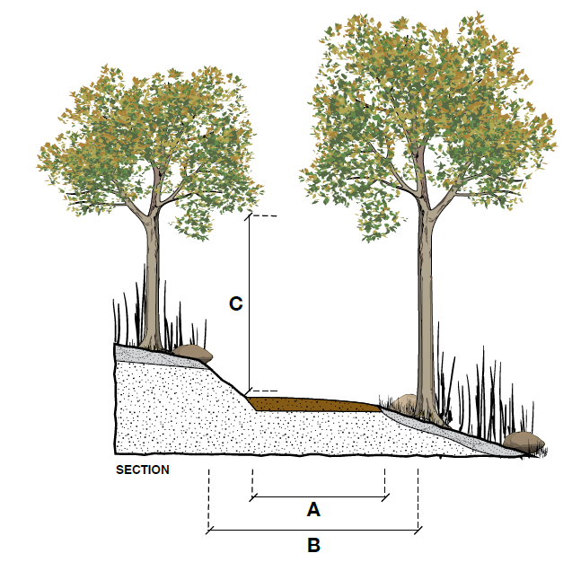 | Example - Trail Corridor Specification –  A – Finished Trail Tread - 600mm  B – Vegetation clearing width – 900mm  C – Vertical clearance - 2,200mm
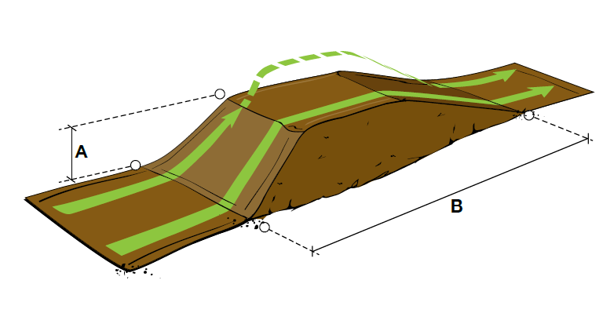 | Example - Table Top  A – vertical height  B – length
<insert additional features as required>

Construction drawings are required for any constructed feature
Construction drawings are required for any constructed feature

