

FLORA TAKING (SANDALWOOD) LICENCE
WILD STANDS APPLICATION KIT

2026/27 SEASON

Applications must be RECEIVED by Department of Biodiversity, Conservation and Attractions (dbca) BY 1600Hrs on 30 june 2026
(APPLICATION CUT-OFF TIME)

This application kit is for applicants applying to take living (green) and dead sandalwood, or dead wood only, in the 2026/2027 season (or for Crown land 3-year applications, where 2026/2027 is the first season of take).

Who can apply?

The following persons can apply for a flora taking (sandalwood) licence:

- For private property, the applicant must be the individual property owner or where the property is owned by a company, the applicant must be an office holder for the company.
- For Crown land where native title has been determined, the applicant must be the relevant Prescribed Body Corporate (PBC) representative or must have an Indigenous Land Use Agreement (ILUA) with the appropriate consents sufficient for DBCA’s purposes. DBCA will provide further advice as required.
- For Crown land where native title has not been determined and the area is under native title claim, the applicant must be a registered native title claimant and have approval from all registered claimants.
- For lands vested in the Aboriginal Lands Trust (ALT), the applicant must be a leaseholder or their representative and have approval from the ALT.
- For other Crown land not subject to Native Title (determination or claim), the applicant must be an occupier of that land with written permission of the vested authority.

Applications must be supported by any relevant access to land authorisations from third parties with vested interest in the application area/s.

Licences will only be issued where the applicant’s sandalwood establishment and sustainability plan is assessed by the Department of Biodiversity, Conservation and Attractions (DBCA) as meeting the sustainability actions.

Application contents
An application must contain the following completed and signed Forms.

Please attach any other documentation or communications to support to your application.

DEAD WOOD ONLY

☐ | Form 1 | Application Form (including documentation required to be attached)
☐ | Form 2A | Sandalwood sustainability and establishment plan – dead wood only
☐ | Form 3 | Access to Land Authority for Designated Activity  If required (outlined in Form 1 Section 3 – Application Area)
☐ | Site map/s
☐ | Operational maps
☐ | Evidence that seed used for seeding operations will be of the same provenance as the proposed licence area
☐ | Proposed seeding area map

LIVING (GREEN) AND DEAD WOOD

☐ | Form 1 | Application Form (including documentation required to be attached)
☐ | Form 2B | Sandalwood sustainability and establishment plan – living (green) and dead wood
☐ | Form 3 | Access to Land Authority for Designated Activity  If required (outlined in Form 1 Section 3 – Application Area)
☐ | Site map/s
☐ | Operational maps
☐ | Global Positioning System (GPS) data from inventory (including track-based and plots)
☐ | Evidence that seed used for seeding operations will be of the same provenance as the proposed licence area
☐ | Proposed seeding area map

Submitting an application

By email (recommended) | wildlifelicensing@dbca.wa.gov.au
By mail | DBCA Wildlife Licensing Section  Locked Bag 30  Bentley Delivery Centre WA 6983  Please note that any correspondence sent by mail may result in some delay.
In person | Wildlife Licensing Section (DBCA Head Office)  17 Dick Perry Avenue  Technology Park, Western Precinct, Kensington  Any DBCA regional or district office

Introduction

This application kit is subject to Western Australian biodiversity legislation and the sandalwood sustainability and licensing documents listed in Figure 1 (below). The Santalum spicatum (Sandalwood) Biodiversity Management Programme (2023) can be found at www.dbca.wa.gov.au/management/sandalwood and the CEO Guideline to support the Biodiversity Conservation Regulations: Sandalwood Licensing (Sandalwood CEO Guideline) at www.dbca.wa.gov.au/licences-and-permits/sandalwood-licences.

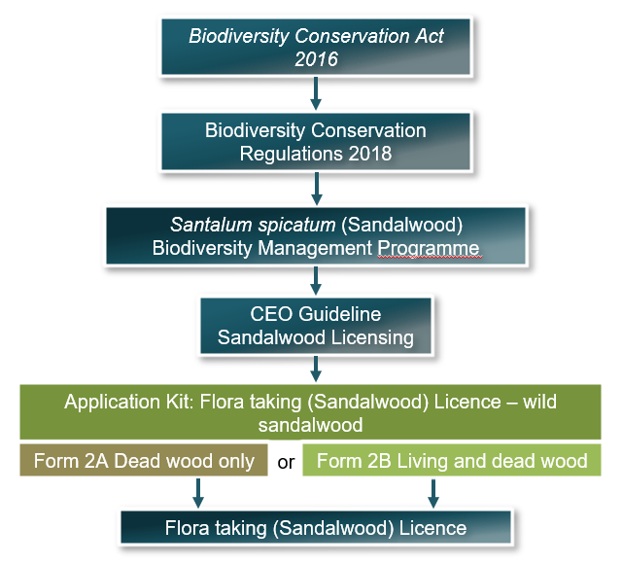
Figure 1. Sandalwood licensing framework

Sandalwood contact information
Wild sandalwood harvesting and licensing administration | Wildlife Licensing Section  (08) 9219 9000  wildlifelicensing@dbca.wa.gov.au
Issues regarding illegal activities or non-compliance with sandalwood licences | Wildlife Protection Branch  (08) 9219 9840  wildlife.protection@dbca.wa.gov.au
Sandalwood conservation and ecologically sustainable use | Sandalwood Project Team  (08) 9219 9000  sandalwood@dbca.wa.gov.au

Regional protocols for the take of sandalwood
Regional protocols for sandalwood take will apply for different subregions of the Interim Biogeographic Regionalisation of Australia (IBRA) (Figure 2). This is based on environmental factors including climate, soils, population viability, and pressures such as previous harvesting history, stock and feral animals, which vary regionally. Table 1 outlines the regional protocols.

Table 1. Regional groupings for the take of living (green) and dead sandalwood.
Regional grouping | IBRA subregions | Explanation and protocols
Semi-Arid Rangelands | Eastern Goldfields, Mardabilla and Southern Cross | The sandalwood populations in the Semi-Arid Rangelands, are generally more broadly distributed across the landscape, occur at higher densities and have better regenerative potential than the populations in other regional groups.  Licences may be issued to take living (green) sandalwood where the CEO has confidence in the applicant’s proposed sustainability measures.
Arid Rangelands | Augustus, Ashburton, Cape Range, Carlisle, Carnegie, Central, Chichester, Dune Field, Fortescue, Hamersley, Lateritic Plain, Mann-Musgrave Block, Nullarbor Plain, Shield, Trainor, Wooramel, Tallering, Edel, Eastern Murchison and Western Murchison | The sandalwood populations in the Arid Rangelands are generally more scattered and may be restricted to creek systems and other mesic habitats, at lower densities and lower regenerative potential, than those in the Semi-Arid Rangelands. In some IBRA subregions the impacts of goats have significantly impacted sandalwood populations, particularly inhibiting natural regeneration. Harvesting in these areas should be restricted to water-gaining areas such as creek lines with upper catchment areas being protected as a seed source.  It is highly recommended that the applicant should demonstrate that the establishment program will be practicably implementable and have a high likelihood of success.  Licences to take living (green) sandalwood will only be granted in circumstances where the CEO has confidence that the proposed sustainability actions will maintain or enhance the viability of the relevant population.
Wheatbelt | Eastern Mallee, Fitzgerald, Geraldton Hills, Katanning, Merredin, Recherche, Western Mallee | Most of the remnant native vegetation has been fragmented and disturbed to a degree that most natural ecological processes such as pollination and seed dispersal have been significantly impacted. Most of the remaining sandalwood populations have previously been extensively harvested. Weeds, livestock and fires also impact significantly on the viability of the remaining populations.  Due to the above, licences to take living (green) sandalwood will only be issued in exceptional circumstances by the CEO and where the application demonstrates an improvement to the relevant population. The application also needs to demonstrate that the site proposed for take contains a viable population of sandalwood with an appropriate level of regeneration.  All living (green) sandalwood trees in these IBRA subregions must be recorded with suitable GPS software and the data supplied with the sandalwood sustainability and establishment plan.

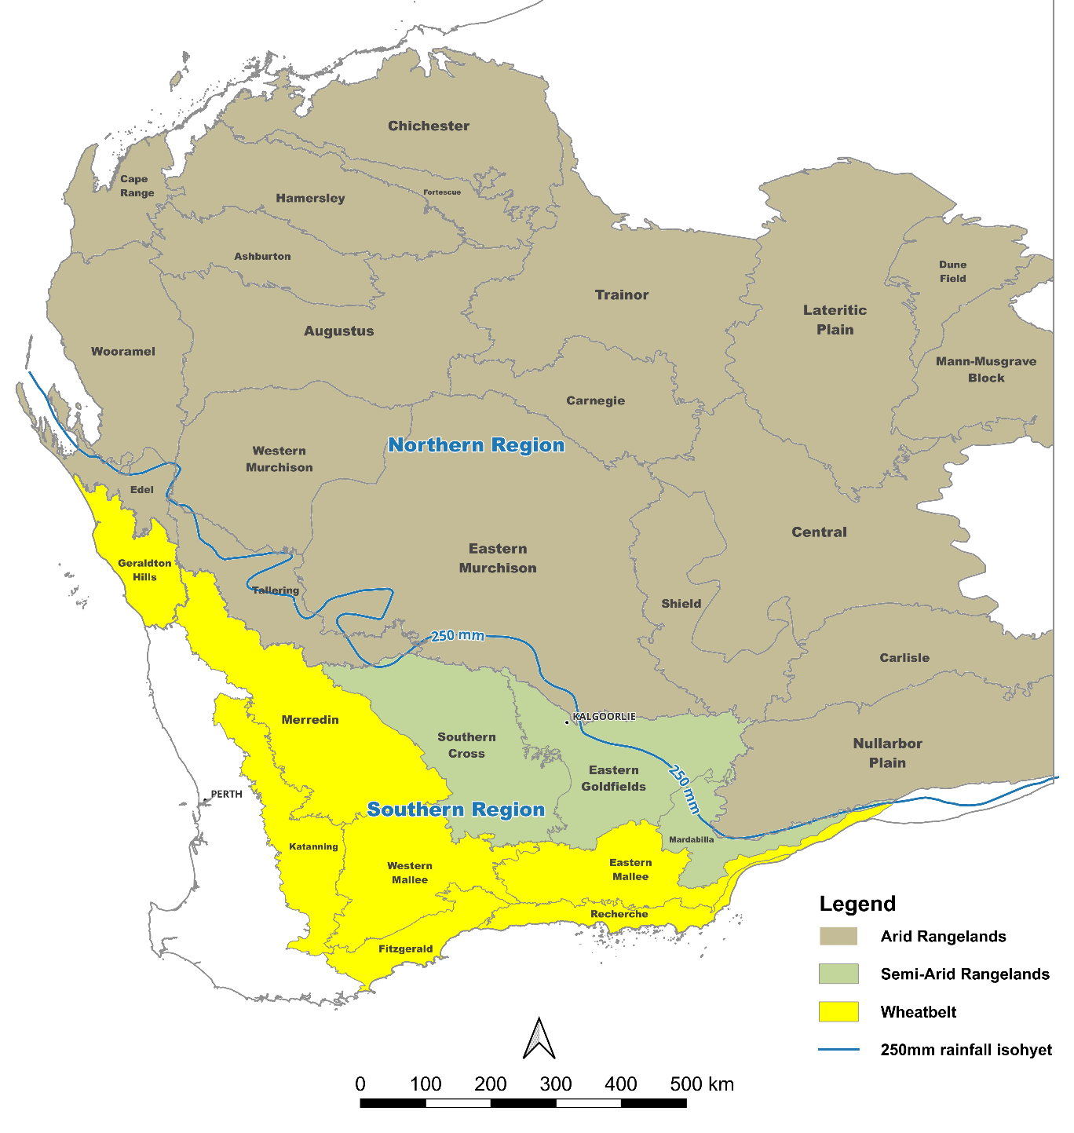
Figure 2. IBRA subregions in which wild sandalwood occurs. These have been grouped into three regions for the purpose of defining regional protocols for the take of sandalwood. The 250 mm rainfall isohyet has been added as a guide to differentiate between northern and southern sandalwood genetic provenances. However, there is no definitive boundary, as there is likely a transition zone that exists around the climatic zones.

Protocols applicable to all regions

It is required that all living (green) sandalwood trees that are taken are marked by a GPS at the time of harvest, and this information must be supplied to DBCA.

The sandalwood sustainability and establishment plan/s for living (green) and dead wood must include the relevant inventory data, analysis and interpretation. Following the DBCA guidelines for conducting inventory is highly recommended and these guidelines are available within Form 2B.

Seeding

Sandalwood seeding is a condition of all flora taking (sandalwood) licences. With reference to Figure 2:

  - licences issued for the Wheatbelt sandalwood region (see Figure 2) require two (2) kilograms of sandalwood seeds to be planted for each tonne (both living (green) and dead) taken. This is because germination rates in these areas are generally higher than for the other regions.
  - licences for all other IBRA subregions require five (5) kilograms of sandalwood seeds to be planted for each tonne (both living (green) and dead) taken. This is because germination rates in these regions are generally lower in comparison to the Wheatbelt.

Sandalwood seed should preferably be sourced from the IBRA subregion or, if unavailable, from plantations of the same genetic provenance as the region in which the licence is being applied for; either the northern region or the southern region. These regional genetic provenances are generally separated by the 250 mm rainfall isohyet (Figure 2). DBCA requires information on seeding strategy as part of conditional return requirements. Information must include seeding site, quantity, seed provenance and seed supplier.

For Crown land, a Regulation 60 ‘Flora Taking (commercial purposes) Crown land licence’ or a Regulation 61 ‘Flora Taking (other purposes) Crown land licence’ is required to collect seed for the purposes of seeding.

The sandalwood sustainability and establishment plan should explain how the seed is to be planted. As a guide, fresh seeds should be planted to a depth of 10–40mm on the south facing leaf drip line of suitable host species such as Acacia species (wattle), Casuarina species, Senna species, or Eremophila species.

Actions for sandalwood sustainability must include seeding programs.

Inspections

For applications that satisfy the mandatory (Stage 1) criteria of sections 15 of the Sandalwood CEO Guideline, a DBCA authorised officer will contact the applicant to arrange an inspection of the proposed harvest and seeding areas. Please note the following:

- Inspections will ideally be scheduled for a time between July-August 2026.
- An inspection fee will apply to each property inspected. Inspection fees should be discussed with the inspecting officer prior to inspection. The fee will be invoiced following an inspection.
- The inspection fees are:
  - not more than 1 hour - $65
  - more than 1 hour but not more than 3 hours - $130
  - more than 3 hours but not more than 5 hours - $260
  - more than 5 hours - $520
- The applicant must be familiar with and be able to guide DBCA officers in the field to the proposed sandalwood harvest locations as specified in the sustainability and establishment plan. It is highly recommended that application inventory information (optional for Form 2A) is accompanied by GPS data and follows the recommended DBCA inventory guidelines as provided in Form 2B. An inspection may cease if it becomes evident that the applicant cannot verify proposed locations and quantities in the field.
- Following the inspection, a sandalwood inspection report will be prepared by the authorised officer to inform the criteria assessment process (Stage 2 criteria) set out in section 17 of the Sandalwood CEO Guideline. This includes confirming the location and quantity of sandalwood, and suitability of sites for establishment.

Licences

Licences may be issued for approved applications, subject to available quantities. Quantities available from 2026/27 season onwards are subject to the review of the 2015 Sandalwood Order, as this current order is in place until 31 December 2026. A new Order will need to be set to specify new limits. For updates on this process please refer to www.dbca.wa.gov.au/management/sandalwood or email sandalwood@dbca.wa.gov.au to be added to the mailing list for updates.

FORM 1

APPLICATION FOR FLORA TAKING (SANDALWOOD) LICENCE
WILD STANDS

Pursuant to Regulation 67 of the Biodiversity Conservation Regulations 2018

IMPORTANT
- All details must be completed, including signing section 8. Declaration by applicant and selecting the payment method.
- It is recommended that applicants familiarise themselves with the Sandalwood CEO Guideline.
- Please ensure you have read the information above before commencing this application.
- Where there is insufficient space for a question, please attach it to your application referencing the relevant form and section. Please attach any other information that may support your application.
- This application relates to the take of sandalwood only. If your proposed operations will involve or result in damage to or clearing of other native vegetation you will need to apply for a clearing permit (Environmental Protection Act 1986 (EP Act) and its subsidiary legislation).

1A. Applicant details
Mr / Mrs / Ms / Dr | First name
 | Other names (middle)
 | Surname
Residential address
Suburb |  |  |  | Postcode |  |  |  | State
Postal address
Suburb |  |  |  | Postcode |  |  |  | State
Phone contact number |  |  |  | Date of Birth | / /
Email:
Consent to approve persons for application/licence correspondence
Do you as applicant provide consent for anyone other than yourself to correspond in writing with DBCA on matters relating to this application or associated licence including approvals, authorisations, amendments or further information? |  |  |  |  |  | ☐ | Yes |  | ☐ | No
If yes, please provide each individual’s details name, and confirm contact details (email address) for written communications.
1B. Applicant Eligibility (select one)
‘Application Area’ is the area to which this application to take sandalwood relates.
For the Application Area the applicant is: |  |  |  |  |  |  |  |  | Must select one
Private property |  | Individual owner |  |  |  |  |  |  | ☐ | Yes
 |  | Company owner representative  (office holder with written approval of the board) |  |  |  |  |  |  | ☐ | Yes
Crown land – Native Title Determined |  | Relevant PBC representative  (CEO, Director) |  |  |  |  |  |  | ☐ | Yes
 |  | Representative with Indigenous Land Use Agreement (ILUA) with PBC |  |  |  |  |  |  | ☐ | Yes
Crown land – Native Title Claim |  | Native Title claimant  (with written approval of all other claimants) |  |  |  |  |  |  | ☐ | Yes
Lands vested in the ALT |  | Leaseholder or their representative  (with written approval of ALT) |  |  |  |  |  |  | ☐ | Yes
Crown land not subject to Native Title (determination or claim) |  | Occupier  (with written permission of vesting authority) |  |  |  |  |  |  | ☐ | Yes

2. Prior Convictions
Have you been convicted of any wildlife related offence in the past 5 years? | ☐ | Yes | ☐ | No
If yes, please provide details (offence, date)

3. Application Area/s
- A separate ‘Form 2A’ or ‘Form 2B’ must be completed for each application area
- Each area must be given an alphabetical reference, starting at A (‘A’ ‘B’, ‘C’ etc). (Attach further areas if necessary).
Which area/s are you proposing to harvest sandalwood from for this application?
- To include land title details (for example, ‘Location 1234 on Plan 765, Land District’).
A.

B.

C.

Provide the following information relevant to an applicant for Application Area type:
Area type | Applicant | Documents required
Private property | Individual owner | - Copy of Title Deed | ☐
Private property | Company owner representative (office holder with written approval of the board) | - Copy of Title Deed | ☐
Private property |  | - Written evidence of resolution from the Company Board that this applicant is authorised to make the application on behalf of the company | ☐
Private property |  | - Form 3 – Access to land from company to undertake designated activity for the Application Area | ☐
Crown land – Native Title Determined | Relevant PBC representative (CEO, Director) | - Native Title Name | ☐
Crown land – Native Title Determined | Relevant PBC representative (CEO, Director) | - Name of PBC | ☐
Crown land – Native Title Determined | Relevant PBC representative (CEO, Director) | - NT Determination summary¹, including extract that shows NT is consistent with commercial sandalwood harvest | ☐
Crown land – Native Title Determined | Relevant PBC representative (CEO, Director) | - Written evidence of resolution from the PBC Board that this applicant is authorised to make the application on behalf of the company/organisation | ☐
Crown land – Native Title Determined | Relevant PBC representative (CEO, Director) | - Form 3 – Access to land authorisation from all third parties with vested interests for each application area (where applicable) | ☐
Crown land – Native Title Determined | Representative with Indigenous Land Use Agreement (ILUA) with PBC | - Native Title Name | ☐
Crown land – Native Title Determined |  | - Name of PBC | ☐
Crown land – Native Title Determined |  | - ILUA summary, including extract that shows ILUA arrangement is consistent with commercial sandalwood harvest | ☐
Crown land – Native Title Determined |  | - Form 3 – Access to land authorisation from all third parties with vested interests for each application area (where applicable) | ☐
Crown land – Native Title Claim | Native Title claimant  (with written approval of all other claimants) | - Native Title Claim details² (claim name, National Native Title Tribunal number, Federal Court number. | ☐
Crown land – Native Title Claim |  | - Written consent from every other native title claimant registered for this claim | ☐
Crown land – Native Title Claim |  | - Form 3 – Access to land from registered NT representative body to undertake designated activity for the Application Area | ☐
Crown land – Native Title Claim |  | - Form 3 – Access to land authorisation from all third parties with vested interests for each application area (where applicable) | ☐
Lands vested in the ALT | Leaseholder or their representative  (with written approval of ALT) | - ALT vesting details (name and reserve no.³ | ☐
Lands vested in the ALT |  | - Written evidence from ALT that this applicant is a leaseholder or leaseholder representative and approved to make application. | ☐
Lands vested in the ALT |  | - Form 3 – Access to land from company to undertake designated activity for the Application Area | ☐
Lands vested in the ALT |  | - Form 3 – Access to land authorisation from all third parties with vested interests for each application area (where applicable) | ☐
Other Crown land  (no ALT lease, Native Title determination or claim) | Occupier  (with written permission of vesting authority) | - Form 3 – Access to land from vesting authority to undertake designated activity for the Application Area | ☐
 | Occupier  (with written permission of vesting authority) | - Form 3 – Access to land authorisation from all third parties with vested interests for each application area (where applicable) | ☐

¹ Copies of determinations can be found here
² Details of registered native title claims can be found here
³ Reserve numbers can be found here

4. Commercial sheep or goat enterprises
Are any of the above proposed application areas for the take of sandalwood subject to commercial sheep or goat enterprises? | ☐ | Yes | ☐ | No
If yes, please confirm that the following will be met where required by licence conditions:
- permanent exclusion of commercial grazing from remnant vegetation areas that contain living (green) sandalwood as demonstrated by covenants on the title of the land; |  |  | ☐ | Yes
- construction of livestock exclusion fencing; and |  |  | ☐ | Yes
- control of feral herbivores in grazing exclusion areas for the first five years of establishing regeneration. |  |  | ☐ | Yes

5. Threatened and priority flora and fauna; and threatened and priority ecological communities
Are the threatened and priority flora database search results¹ for each application area attached? (required) | ☐ | Yes
Are the threatened and priority fauna database search results¹ for each application area attached? (required) | ☐ | Yes
Are the threatened and priority ecological communities database search results¹ for each application area attached? (required) | ☐ | Yes
How will threatened and priority species in the harvest area will be protected from sandalwood operations? (Attach further information if necessary).
¹ Information on how to request a database search can be found at dbca.wa.gov.au/management/threatened-species-and-communities/resources/threatened-species-and-communities-database-searches.
6. Protecting heritage and culture
It may be necessary for applicants to seek permissions or authorisations to lawfully and appropriately carry out their activity. It is the applicant’s responsibility to ensure that all other relevant permissions are obtained before seeking a licence (cultural heritage due diligence).  Confirm that the operations will comply with the Aboriginal Heritage Act 1972. |  |  | ☐ | Yes
Does the application area have culturally sensitive areas or locations?  If yes, provide details if culturally appropriate to do so. | ☐ | Yes | ☐ | No
How will these sites/locations be protected from sandalwood operations?
If there are any other heritage considerations relevant to this application, please detail how these will be protected during operations. Provide copy of search results.

7. Third party interests
Are any of the locations subject to any third-party interests (e.g., pastoral lease, mining lease, Aboriginal Lands Trust lease)? (Attach further rows if necessary). |  | ☐ | Yes | ☐ | No
If yes, attach Access to Land Authorisations (Form 3) for each. |  | ☐ | Attached
Type
Type
Type

8. Covenants
Are any of the locations subject to any covenants or similar? | ☐ | Yes | ☐ | No
If yes, attach documentation (including covenant terms/conditions) | ☐ | Attached

9. Authorised persons
A licence granted to an individual may also authorised the following -
a) other specified persons to carry out the activities under the licence (or assist in carrying out such activities);
b) other persons of a specified class to carry out activities (or assist in carrying out such activities).
Will other specified persons (or persons of a specified class) be undertaking licensed activities on behalf of the licence holder? | ☐ | Yes | ☐ | No
If yes, please provide a summary of the proposed arrangements

9. Storage locations
List each location where you will store sandalwood (taken under this licence) for the purpose of supply.
To be stated as per land title details (e.g. ‘Location 1234 on Plan 765, Land District’).
Note 1 - The licensed taking locations will be listed as Storage Locations automatically (there is no need to list these in this section).
Note 2 - Sandalwood Tracking Forms (STFs) are required for moving/transporting specifically controlled sandalwood from the place sandalwood is taken to another place, or from a place sandalwood is stored to another place.

10. Duration of licence and fees
Payment details at bottom of this form.
☐ | 1-year licence application | Fee = $415 ($130 refund if licence not issued)
☐ | 3-year licence application (Crown land only) | Fee = $675 ($390 refund if licence not issued)

11. Collection, use and disclosure of personal information
The Department of Biodiversity, Conservation and Attractions (DBCA) is committed to protecting information provided by you in accordance with state privacy laws. Information that you provide will be used for licence monitoring and compliance purposes, to inform you of any licence or legislative requirements or changes and may be used to seek your feedback on wildlife related licensing and legislation.
A licence may not be issued if the required information is not provided.
The information provided may also be made available to any authorised law enforcement agency if required.

12. Declaration by applicant
☐ | Yes | I understand that there are penalties for making a false declaration or providing false information and that any licence issued as a result of false information will be cancelled or revoked, and it may affect my ability to hold biodiversity conservation licences in the future. All details provided by me to DBCA in relation to this application are true and correct, and I consent to the use and disclosure of information for the purposes described in the ‘Collection, use and disclosure of personal information section above.
Signed: |  |  | Date: | ____/____/________

PAYMENT METHODS
☐ | CHEQUE /  MONEY ORDER (enclosed) | Payable to Department of Biodiversity, Conservation and Attractions (“DBCA”) to be attached to completed application form.
☐ | EFT TRANSFER | Acct Name: DBCA  BSB: 066-040  Account No.: 11300006 | Ref: “67, Surname, Initial”  (max 18 characters)
☐ | CREDIT CARD (details below)

*Any details below will be detached and destroyed once payment is processed. Please print clearly.

VISA / MASTERCARD (Please circle)
Name of Cardholder: ____________________ Signature: _____________ Amount: $ _________
Card No: ___ ___ ___ ___ ___ ___ ___ ___ ___ ___ ___ ___ ___Expiry Date: __/________

FORM 2A

Sandalwood sustainability AND ESTABLISHMENT plan
– Dead wood ONLY

IMPORTANT
- Dead sandalwood is defined in the Sandalwood CEO Guideline as sandalwood that has died through natural causes and where there is no indication of human-caused pre-mortem injury. Refer to the Sandalwood CEO Guideline for more information.
- This form serves as a template with associated guidelines for applicants to prepare Sandalwood sustainability and establishment plans for the take of dead wood only. Applicants may choose to prepare their own Sandalwood sustainability and establishment plan without using this template, provided the information requested in this document is provided in adequate detail to make an assessment against Stage 2 criteria of the Sandalwood CEO Guideline.
- Commitments included in this document may be included as conditions of any ensuing licence should all criteria contained within the Sandalwood CEO Guideline be met.
- The sustainability and establishment plan must include a description of the stratification/mapping of optimal sandalwood habitat and actions proposed for promoting sustainability. Figure 3 provides an example of the steps to be addressed. Any inventory is optional (recommended if there are future plans to apply for harvest/take of living (green) sandalwood).
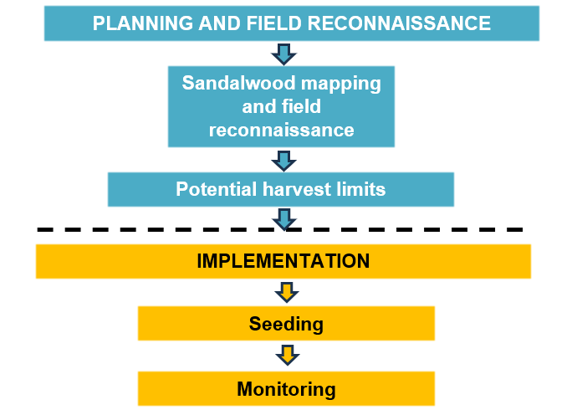
Figure 3. Sustainability and establishment plan process for the take of dead wood only.

- Information provided in this document may be used by DBCA to inform broader sandalwood conservation management.
- The plan and maps do not need to be produced with a computer but must be clear and legible. Additional lines and space may be inserted into the text and map boxes and additional supporting information may be attached.
- Comments highlighted in yellow have been included throughout this template to provide guidance in completing the requirements. These should be deleted once the document is completed.
COVER PAGE

- Plan preparation | Name | Signature |  | Date
Prepared by:
Prepared for:
2. Application Area
Application area of proposed harvest area from Form 1
(for example, ‘A’, ‘B’, ‘C’ etc)
Application Area
To be stated as per land title details (for example, ‘Location 1234 on Plan 765, Land District’)
Sandalwood region (refer to Figure 2)

Insert or attach maps

Site map

Provide a map that should include the following:
- The location of the application area in relation to public roads and relevant access tracks.
- The areas where sandalwood habitat occurs on the property.

Operational map/s

Provide a map/s with the following locations and information:

- areas where harvesting is proposed (GPS way points not required for dead wood only harvesting)
- areas where sandalwood has previously been established
- areas of past harvesting
- proposed seeding locations
- existing fencing
- fencing to be constructed (optional for dead wood only harvesting)
- stock exclusion areas
- areas where control of invasive animals is proposed (if applicable and optional for dead wood only harvesting)
- sandalwood protected (permanent no harvest) areas
- sensitive areas (where culturally appropriate).

4. PLANNING AND FIELD SURVEY

4.1 Mapping of sandalwood habitat

Please provide a map showing where the sandalwood occurs on the proposed licence area and complete Table 1. For more information on mapping of sandalwood habitat please refer to Form 2B – Living (green) and dead sandalwood sustainability and establishment plan.

Table 1. Results of desktop study identifying potential sandalwood habitat.
Licence application area/s
Note this information is to match the information under ‘Application Area/s’ in Form 1
Total area of proposed licence application¹ (hectares)
Area of potential sandalwood habitat (hectares) per area/zone (A):
- Area/Zone 1 (or name)
- Area/Zone 2 (or name)
- Area/Zone 3 (or name)
- Insert additional areas/zones as required
- Identify intensively dead areas (e.g. bushfire), to be separately assessed
Total area of potential habitat (hectares)
¹For example, private property, Aboriginal Lands Trust reserve, Native Title Determination Area.

4.2 Field reconnaissance

As a minimum, vehicle-based reconnaissance is essential to ground truth the approximate area of dead sandalwood based on the stratification/mapping.

Additional field survey can be undertaken as a means of better estimating the sandalwood dead wood resource. If any field surveys (track-based or plots) for dead sandalwood are undertaken (optional), please follow inventory guidance within Form 2B. This kit also provides images of different categories of dead sandalwood.

Although not compulsory for a dead wood application, surveys are recommended, especially if considering take of living (green) sandalwood in future years. In addition, this baseline information is useful for regeneration monitoring.

5. PROPOSED TAKE

Quantities applied for can be determined based on the habitat stratification and field reconnaissance. If the applicant wishes or needs to better estimate the quantity of take that is proposed, please refer to the ‘Proposed Take’ section in Form 2B.

6. IMPLEMENTATION

In this section, the applicant should provide information on proposed sandalwood conservation measures, including seeding and other silviculture, that will support this application. The information can be provided in the tables below.

6.1 Seeding

6.1.1 Past seeding operations (if applicable)

Has sandalwood been intentionally established (planted) on this location in the past, for regeneration purposes under a condition of a licence or authority (where it cannot be taken for supply)? If yes, it is recommended that GPS data for these areas is provided. |  |  | ☐ | Yes (complete below) |  | ☐ | No |  | ☐ | Unsure
Year | Location | Quantity of seed sown | Area covered (hectares) |  | Recruitment success (where this information is available)
 |  |  |  |  | % success |  |  | Stems/hectare

6.1.2 Proposed seeding strategy

Discuss the target locations for the seeding that will help to ensure regeneration success e.g. evidence of regeneration occurring at the site, sufficient host species, areas are not subject to substantial threatening processes (e.g. grazing animals), and water gaining areas (applicable to Arid regions).

As mentioned earlier under the Regional Protocols for the take of sandalwood, either two (2) (Wheatbelt only) or five (5) kilograms (all other regions) of sandalwood seed is to be planted for each tonne taken.

Where will the seed be collected/sourced from? Seed should preferably be of the same genetic provenance as the sandalwood in the licence area. If the seed will be sourced from plantations, please provide evidence that the appropriate provenance will be provided, from either the northern (arid) region or southern (semi-arid) region (refer to regional protocols Figure 2).
How many kilograms of sandalwood seed (per tonne dead wood harvested) will be sown each year? (refer to regional protocols)
Where will the seed be sown? If additional seeding is undertaken in areas outside of harvesting operations, please indicate where. Areas planned for seeding should be illustrated on a map. Note that applications that show a more favourable conservation outcome will be ranked higher preference in the event that there is insufficient quota available for the amount of applications.

6.1.3 Seeding methods

Discuss how the seed will be planted, including timing of planting, selection of suitable host species, depth of planting and equipment.

Sandalwood seeding can be completed by either hand planting or mechanical means. It is recommended that sowing occur around January–May. This is the best time to target for increased likelihood of successful regeneration, due to the winter rainfall, which is essential for germination. Sowing is to occur by way of loosening the soil and burying the seeds to a depth of 10–50 mm. Sandalwood seedlings normally emerge in July–September.

Fresh seed from the previous season is preferred. Plant a maximum of four (4) seeds per host at about one (1) metre from the host and within the dripline of hosts, preferably on the south or south-east side of hosts.

Preferred host species include Acacia (wattle) species, primarily jam (Acacia acuminata) but also mulga (A. aneura), wodjil (A. resinimarginea) and curara (A. tetragonophylla). Other preferred host species include Eremophila species (broom bush, emu bush, poverty bush), Cassia species (Senna) and Casuarina species (sheoak, black oak) (Loneragan, 1990).

6.1.4 Monitoring of seeding success

Discuss what monitoring will be undertaken and what actions will be taken if germination has not been successful. DBCA intends to in future provide a guideline template for monitoring of seeding success.

FORM 2B

Sandalwood sustainability AND ESTABLISHMENT plan
– Living (GREEN) and dead wood

IMPORTANT
- Dead sandalwood is defined in the Sandalwood CEO Guideline as sandalwood that has died through natural causes and where there is no indication of human-caused pre-mortem injury. Refer to the Sandalwood CEO Guideline for more information.
- This form serves as a template with associated guidelines for applicants to prepare Sandalwood sustainability and establishment plans for the take of living (green) and dead sandalwood. Applicants may choose to prepare their own Sandalwood sustainability and establishment plan without using this template, provided the information requested in this document is provided in adequate detail to make an assessment against Stage 2 criteria of the Sandalwood CEO Guideline.
- Commitments included in this document may be included as conditions of any ensuing licence should all criteria contained within the Sandalwood CEO Guideline be met.
- The sustainability and establishment plan must include a description of how potential harvest estimates were derived and actions proposed for promoting sustainability. Figure 3 provides an example of the steps to be addressed.
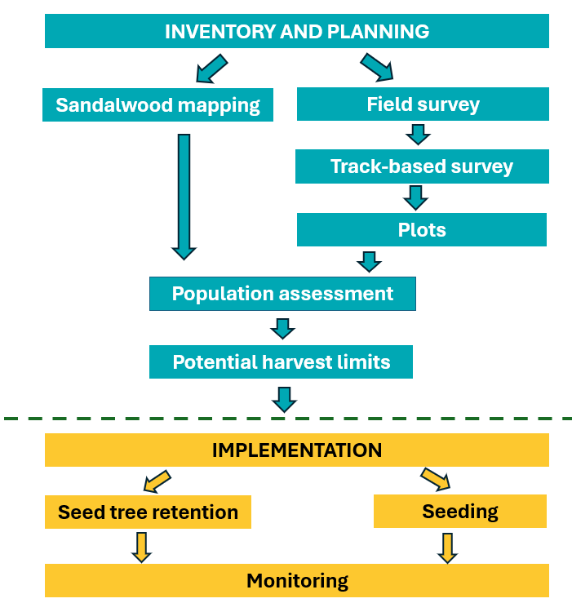
Figure 3: Sustainability and establishment plan process for the take of living (green) and dead wood.
- Information provided in this document may be used by DBCA to inform broader sandalwood conservation management.
- The plan and maps do not need to be produced with a computer but must be clear and legible. Additional lines and space may be inserted into the text and map boxes and additional supporting information may be attached.
- Comments highlighted in yellow have been included throughout this template to provide guidance in completing the requirements. These should be deleted once the document is completed.

COVER PAGE

- Plan preparation | Name | Signature |  | Date
Prepared by:
Prepared for:
2. Application Area
Application area of proposed harvest area from Form 1
(for example, ‘A’, ‘B’, ‘C’ et cetera)
Application Area
To be stated as per land title details (for example, ‘Location 1234 on Plan 765, Land District’)
Sandalwood region (refer to Figure 2)

¹ Reserve numbers can be found here
² Copies of determinations can be found here
³ Details of registered native title claims can be found here

Insert or attach maps

Site map

Provide a map that should include the following:
- The location of the application area in relation to public roads and relevant access tracks.
- The areas where sandalwood habitat occurs on the property.

Operational map/s

Provide a map/s with the following locations and information:

- areas where harvesting is proposed
- areas where sandalwood has previously been established
- areas of past harvesting
- proposed seeding locations
- existing fencing
- fencing to be constructed
- stock exclusion areas
- areas where control of invasive animals is proposed (if applicable)
- sandalwood protected (permanent no harvest) areas
- sensitive areas (where culturally appropriate).

4. INVENTORY AND PLANNING

4.1 Mapping of sandalwood habitat

The method used to identify and map the distribution of sandalwood habitat on the proposed licence areas should be discussed here.

Sandalwood occurrence is usually patchy and scattered and will probably not occur uniformly throughout a proposed licence area. It does not generally occur in spinifex or sand plain vegetation, where fires occur too frequently for its establishment and persistence. These areas should therefore be excluded from the potential resource estimations. In the Arid Rangelands and deserts, sandalwood is more likely to be found along creeks. It is therefore important only to estimate the area covered (hectares) by the better sandalwood habitat. This will allow the applicants to estimate as accurately as possible, the total area of sandalwood habitat considered for the proposed licence, so that an appropriate harvest level may be applied for, and the requirements of an associated seeding program, better understood. The method for mapping can be part desk-top and part field survey. Local knowledge and maps, including aerial imagery, Department of Primary Industries and Regional development (DPIRD) land systems (Tille, 2006), Beard’s vegetation associations (Beard et al., 2013), topographical maps, fire history maps, grazing and harvesting history, and field observations, are all useful for mapping. The populations can be mapped as separate harvest zones, as appropriate. Zones can be based on geographical boundaries and/or similar habitat (vegetation associations or land systems). Refer to Table 1.

Please provide a map showing the optimal sandalwood habitat on the proposed licence area and complete Table 1.

Table 1. Results of desktop study identifying potential sandalwood habitat.
Licence application area/s
Note this information is to match the information under ‘Application area/s’ in Form 1
Total area of proposed licence application¹ (hectares)
Area of potential sandalwood habitat (hectares) per area/zone (A):
- Area/Zone 1 (or name)
- Area/Zone 2 (or name)
- Area/Zone 3 (or name)
- Insert additional areas/zones as required
- Areas of concentration of dead wood (e.g. from bushfire or drought)—these may be separately assessed
Total area of potential habitat (hectares)
¹ For example, private property, Aboriginal Lands Trust reserve, Native Title Determination Area.

4.2 Field survey

Surveys can be used to ground-truth the stratification/mapping, and as a means of estimating the sandalwood resource and hence the proposed take for the licence application. Briefly discuss how the field survey/s was undertaken, for example, rapid track-based surveys (also called resource level inventories) and standard monitoring through plot establishment. Note that DBCA plans to develop a guideline for sandalwood surveys.

It is recommended that a track-based survey method is used for large areas. For smaller areas it may not be necessary, particularly if the inventory plots constitute a representative sample of the total proposed licence area. A track-based survey will provide a relatively rapid, landscape-scale assessment of the condition of the sandalwood population/s on the licence application area. It should be noted however, that all inventories have an associated level of imprecision, and past work has suggested the general field survey techniques described herein may underestimate the amount of sandalwood resource and regeneration because of several factors including inaccuracies in observing seedlings, saplings and trees from a moving vehicle. To better understand current population status, model harvesting implications and monitor future trends, it is necessary to establish an appropriate number of inventory plots which are surveyed on foot and in which all sandalwood plants are measured and recorded, and which provide a greater level of accuracy and precision (see 4.2.2 Inventory plots).

4.2.1 Rapid track-based survey

A rapid track-based survey is intended as reconnaissance to refine the stratification process and provide an estimate of the potential resource.

The rapid track-based survey should include the following:

- Driving a selection of roads and tracks that suitably cover a representative area of the proposed licence area, and cross through all the land systems/vegetation associations/habitats which have been identified as having the highest probability of sandalwood occurrence during the mapping process.
- Drive at a slow speed no faster than 20km/hr and record all living (green) and dead wood trees within a distance of 30m on both sides of the track.
- Cover at least one per cent of the surface area of the stratified sandalwood habitat (see Table 2).

Table 2. Guidance for calculation of the track-based survey distance required to meet the one per cent or higher (if desired) sampling rate.
Area/Zone | Potential habitat area in hectares (A) (Table 1) | Survey area (to meet the minimum 1% sampling effort required) |  | Distance along track to survey (divide by 60m)
Area/Zone | Potential habitat area in hectares (A) (Table 1) | Hectares (B) | Square metres | Distance along track to survey (divide by 60m)
Example | 20,000 | 200 | 200,000 | 3,333m (3.3km)
Area/zone 1
Area/zone 2
Insert addition areas/zones as required

- A tally of all living and dead standing sandalwood trees should be recorded. The following shows the different suggested categories for sandalwood trees.
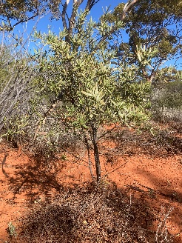 | 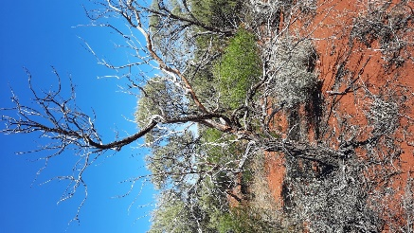 | 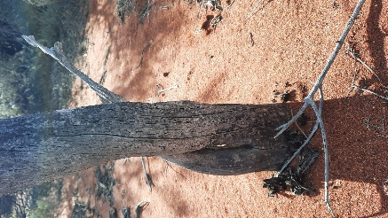 | 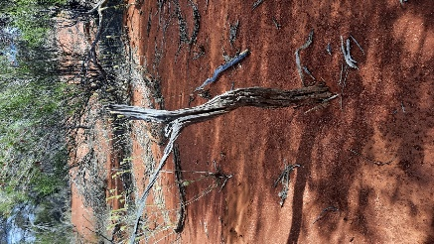
Living  Has leaves. | Dead with bark  No leaves.  Some bark on tree.  Sapwood may have hints of yellow.  May have fine twigs still attached to branches. | Dead grey  No bark.  Sapwood is mostly intact and a smooth grey colour.  Fine twigs have mostly fallen. | Dead withered¹  Sapwood is eroded.  Surface is corrugated and rilled.  Only the stem and a few major branches remain.
¹ This dead withered category also includes pieces that lie on the ground, although it is not necessary to count dead withered on the ground as it can provide additional habitat.

- Other categories can be added as desired. In addition, during inventory observations can be made as appropriate/desired for planning purposes e.g. observations of fire damage.

- For the living (green) sandalwood, the over bark diameter at 150 mm above the ground of each sandalwood within a 30-metre strip either side of the one track driven, is estimated and recorded (see Table 3) in the following size classes:

  - 0–24 mm
  - 25–74 mm
  - 75–125 mm
  - 126–174 mm
  - >175 mm

All routes travelled must be recorded using a GPS device and a map produced to illustrate the extent of the rapid track-based survey. The total distance of the survey and the sample size as percentage of the licence application area, must be provided. Appendix 1 provides a suggested blank track-based survey sheet.

Table 3. Resource level data collected during rapid tracked-based survey.
Area/Zone (number or name) | Hectares¹ | Total stems² and stems/hectare³ in size classes measured at 150 mm above ground level (diameter) |  |  |  |  |  | Dead wood
Area/Zone (number or name) | Hectares¹ | Stems/  Stems per hectare | 0–24 mm | 25–74 mm | 75–125 mm | 126–174 mm | >175 mm | Dead with bark | Dead grey | Dead withered
1 |  | Stems
1 |  | Stems per hectare
2 |  | Stems
2 |  | Stems per hectare
3 |  | Stems
3 |  | Stems per hectare
Insert additional rows as required
Totals |  | Stems per hectare
¹ As per Table 1.
² Calculate total stems for the entire zone area.
³ Divide total stems by number of hectares of the zone to calculate stems/hectare.

4.2.2 Inventory plots

Inventory plots are necessary to validate the results from the track-based survey and provide a better understanding of the condition of the sandalwood population in the proposed harvesting area/s (particularly regarding the level of recruitment). It is essential to understand population demographics prior to any harvest operations, as this needs to be considered when developing a seeding strategy and possibly other licence conditions. In addition, the inventory provides baseline data on the existing recruitment levels which is required to be able to measure success of seeding operations. The plots can be used subsequently for future monitoring, including to measure the level of success of the sustainability and establishment plan.

In this section discuss how many inventory plots were established and where they were laid out. The GPS data must be provided.

The survey effort and plot design (for example, stream plots) should be based on the size and variability of the mapped potential sandalwood habitat (Table 1) in which harvesting is proposed and the following sampling intensities in the table below are recommended. This can be adjusted as appropriate, for example, for a more variable environment, more plots may be suitable.

The number of plots recommended is shown in the table below.
Licence area | Recommended minimum number of 6-hectare plots
≤ 20 hectares | Up to 1 plot
21-200 hectares | 1-2 plots
201-1000 hectares | 2 plots per 200 hectares, with a minimum of 2 plots
> 1000 hectares | The total area of inventory plots should cover 10% (within areas of optimal/stratified sandalwood habitat) of the track-based survey route. For example, if 300 km within optimal sandalwood habitat were surveyed along the tracks travelled, 30 plots of 6 hectares each, should be established. The inventory plots should be representative of the variability within the optimal sandalwood habitat. For example, if there are six different land systems or vegetation associations that are considered as optimal sandalwood habitat, then it is recommended that 5 plots should be established in each (where 30 plots for 300km are required to make up a 10% sample).

Inventory plots may have different configurations, for example, horseshoe, stream, and track-based). Each plot should cover six hectares and be one kilometre long and 60 metres wide (30 m either side of the centre line of the plot). Diameter classes can be recorded using a diameter tape or Vernier callipers (precise measurements can be recorded as an option). However, it can be more time efficient to use other methods to record diameter classes for the groups shown in Table 3. Appendix 2 provides a suggested blank plot survey sheet.

It is recommended that the data from the plots recorded on the field data record sheets, are provided in the format shown in Table 3.

Table 3. Size class distribution for the sandalwood population in the proposed licence area.
Zone/Area¹ |  | Living (diameter) |  |  |  |  |  |  | Dead wood
Zone/Area¹ |  | 0–24 mm | 25–74 mm | 75–125 mm |  | 126–175 mm | >175 mm |  | Dead with bark | Dead grey | Dead withered
1 | Stems²
1 | Stems/hectare³
2 | Stems
2 | Stems/hectare
3 | Stems
3 | Stems/hectare
Insert additional rows as necessary
¹ The average values (stems and stems/hectare for each size class) for the plots for each zone/area, are used to populate the table.
² Calculate total stems for the total area for each zone/area in Table 1.
³ Divide total stems by number of hectares of the zone to calculate stems/hectare.

5. POPULATION CONDITION ASSESSMENT

The data from Table 3 should then be analysed to provide an assessment of the population for each licence application area. The data should be illustrated in a graph like the example below (Figure 3). The viability of the sandalwood population/s should be discussed focusing on the level of existing recruitment, as well as threats such as introduced animals and fire. A seeding strategy should focus on ensuring a higher proportion of younger age classes.

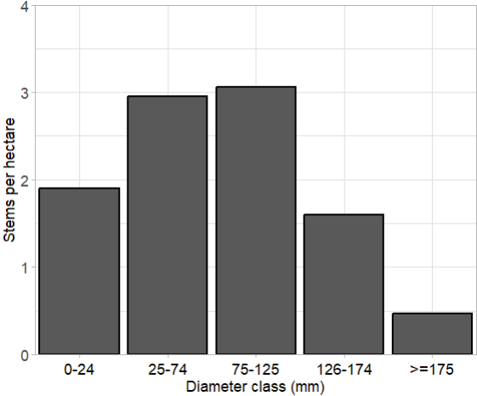
Figure 3. Example of a size class distribution for a sandalwood population.

6. PROPOSED TAKE

In this section, the applicant should identify what quantity of take is proposed, based on any knowledge of previous harvesting history and inventory information above. Any other information relating to the history of land management relevant to sandalwood can also be mentioned in this section as appropriate.

In this section the applicant should identify what quantity of take is proposed, based on any records of whether sandalwood has previously been harvested from the proposed licence areas (Table 4), and the inventory (Table 3) and population viability (Figure 3) information. Any other information relating to the history of land management relevant to sandalwood can also be mentioned in this section as appropriate.

Table 4. Previous levels of harvest in licence application area.
Has sandalwood been harvested from this location in the past? If yes, please provide GPS data of past harvest locations | ☐ | Yes (complete below) | ☐ | No | ☐ | Unsure
Year | Location | Harvester’s details  (Name and licence number) | Living tonnes | Dead tonnes

The data from Tables 1, 2 and 3 should be used with the standard weights for each size class below (Table 5) to estimate the total potential tonnes that could be harvested over the proposed licence area in Table 6.

Table 5. Approximate weight of harvestable size classes.
Stem diameter range (measured 150 mm above ground level) | Approximate weight of sandalwood per living (green) tree
127–150 mm | 18 to 22kg
151–175 mm | 29 to 34kg
176–200 mm | 43 to 51kg
201–225 mm | 62 to 73kg
Dead | 15kg/stem

These quantities must be used as a guide only as quantities are highly variable depending on the number of stems, tree shape, growing conditions and the region in which the tree is located. The quantity of specifically controlled sandalwood per tree does not include twigs. Total estimated quantities can be recorded in Table 6. A more detailed breakdown of the volumes (per size class) can be provided if desired.

Table 6. Potential sandalwood resource.
Year | Area | Area | Total hectares | Harvestable¹ stems/hectare | Harvestable kg/hectare | Total harvestable tonnes
1 | 1 | Living
1 | 1 | Dead
1 | 2 | Living
1 | 2 | Dead
1 | 3 | Living
1 | 3 | Dead
1 | Insert additional rows as required
1 | Totals
¹ Harvestable refers to living trees greater than 126 mm measured at 150 mm above the ground, and dead wood that is intended to be taken (some dead wood, such as in the dead withered found on the ground may be left on site).

6. IMPLEMENTATION

In this section, the applicant should provide information on proposed sandalwood conservation measures, including harvest exclusion areas, retention of seed-bearing trees in proposed harvesting areas, seeding and other silviculture, that will support this application. The information can be provided in the tables below.

6.1 Retention of seed-bearing trees

Discuss how sufficient seed producing trees will be retained at appropriate densities and patterns of distribution in the landscape, including no-harvest zones.

Describe what other measures are proposed to protect and conserve sandalwood at the location, including fire management, minimising compaction and erosion caused by harvest machinery, and avoidance of erosion prone soils/topography.

6.2 Seeding

6.2.1 Past seeding operations

Has sandalwood been intentionally established (planted) on this location in the past, for regeneration purposes under a condition of a licence or authority (where it cannot be taken for supply)? If yes, it is recommended that GPS data for these areas is provided. |  |  | ☐ |  | Yes (complete below) |  | ☐ | No | ☐ |  | Unsure
Year | Location | Quantity of seed sown |  | Area covered (hectares) |  | Recruitment success (where this information is available)
 |  |  |  |  |  | % success |  |  |  | Stems/hectare

6.2.2 Proposed seeding strategy

Discuss the target locations for the seeding that will help to ensure regeneration success e.g. evidence of regeneration occurring at the site, sufficient host species, areas are not subject to substantial threatening processes (e.g. if grazing animals are present measures are in place to protect regeneration from them), and water gaining areas (applicable to Arid regions).

As mentioned earlier under the Regional Protocols for the take of sandalwood, either two (2) (Wheatbelt only) or five (5) kilograms (all other regions) of sandalwood seed is to be planted for each tonne taken.

Where will the seed be collected/sourced from? Seed should preferably be of the same genetic provenance as the sandalwood in the licence area. If the seed will be sourced from plantations, please provide evidence that the appropriate provenance will be provided, from either the northern (arid) region or southern (semi-arid) region.
How many kilograms of sandalwood seed (per tonne living (green) and/or dead wood harvested) will be sown each year? (refer to regional protocols)
Where will the seed be sown? If additional seeding is undertaken in areas outside of harvesting operations, please indicate where. Areas planned for seeding should be illustrated on a map. Note that applications that show a more favourable conservation outcome will be ranked higher preference in the event that there is insufficient quota available for the amount of applications.

6.2.3 Seeding methods

Discuss how the seed will be planted, including timing of planting, selection of suitable host species, depth of planting and equipment.

Sandalwood seeding can be completed by either hand planting or mechanical means. It is recommended that sowing occur around January–May. This is the best time to target for increased likelihood of successful regeneration, due to the winter rainfall, which is essential for germination. Sowing is to occur by way of loosening the soil and burying the seeds to a depth of 10–50 mm. Sandalwood seedlings normally emerge in July–September.

Fresh seed from the previous season is preferred. Plant a maximum of four (4) seeds per host at about one (1) metre from the host and within the dripline of hosts, preferably on the south or south-east side of hosts.

Preferred host species include Acacia (wattle) species, primarily jam (Acacia acuminata) but also mulga (A. aneura), wodjil (A. resinimarginea) and curara (A. tetragonophylla). Other preferred host species include Eremophila species (broom bush, emu bush, poverty bush), Cassia species (Senna) and Casuarina species (sheoak, black oak) (Loneragan, 1990).

6.2.4 Other measures to support sandalwood seeding areas

Discuss what measures will be taken to support sandalwood establishment, including fencing, livestock management (particularly goats and sheep) and feral animal control.

6.2.5 Monitoring of seeding success

Discuss what monitoring will be undertaken and what actions will be taken if germination has not been successful. DBCA intends to in future provide a guideline template for monitoring of seeding success.

Appendix 1. Suggested sandalwood track-based survey sheet

This template is suggested and can be modified as desired.

Date:
Location/Area/Zone:
Run no:
Assessors:
Land/vegetation type:
Geolocation (e.g. GPS reference/waypoint) Start:
End:
Distance travelled (km) | GREEN |  |  |  |  | DEAD |  |  | Comments (e.g. vegetation type)
Distance travelled (km) | NUMBER OF STEMS BY DIAMETER  CLASSES (mm) |  |  |  |  | DEAD WITH BARK | DEAD  GREY | DEAD  WITHERED  (optional) | Comments (e.g. vegetation type)
Distance travelled (km) | 0-24 mm | 25-74 mm | 75-125 mm | 126-175 mm | >175 mm
Totals

Appendix 2. Suggested sandalwood plot survey sheet

The following survey sheet can be used to record sandalwood occurrence and size information. Size classes can be aggregated into broader groupings shown below. More detailed measurements are preferred and encouraged to enable inventory information to be used in broader sandalwood population demographic analysis. This template is suggested and can be modified as desired.
Date:
Location/Area/Zone:
Plot reference:
 | GREEN |  |  |  |  | DEAD
 | NUMBER OF STEMS BY DIAMETER  CLASSES (mm) |  |  |  |  | DEAD WITH BARK | DEAD  GREY | DEAD  WITHERED (optional)
DIAMETER CLASS (mm) | 0-24 mm | 25-74 mm | 75-125 mm | 126-175 mm | >175 mm | DEAD WITH BARK | DEAD  GREY | DEAD  WITHERED (optional)
Totals
Assessors:
Land/vegetation type:
Geolocation (e.g. GPS reference/waypoint) Start:
End:
Plots measures 1km x 60m (6 hectares)
Note: Measure multiple stems separately and record each stem as an individual (e.g. 2 for double and 3 for triple stems).
Comments/observations: e.g. dominant host trees, fire damage.

Form 3 (Crown land only)
ACCESS TO LAND FOR FLORA TAKING (SANDALWOOD)
Pursuant to Regulation 101 of the Biodiversity Conservation Regulations 2018

A person who is authorised to carry out a designated activity under a licence must not, for the purposes of the designated activity, enter land that is not in the possession or under the control of the holder of the licence without written authorisation of an owner or occupier of the land to enter the land and to carry out the designated activity.

Written approval from the landowner or occupier must be attached to the licence during licensed activities.
- Designated activity |  |  | Taking flora (sandalwood) in accordance with a Biodiversity Conservation Regulations 2018 (BC) Regulation 67 Flora taking (sandalwood) licence.
- Landowner/Occupier information
☐ | Landowner/Landowner representative |  |  |  |  | ☐ | Land Occupier (including Native Title holders, Native Title claimant/s, pastoral lessees, mining lessees or other third parties)
Person/Organisation name
Name of the organisation’s authorised representative
Position of the representative within the organisation
Phone contact number
Location details
- Person authorised to take flora (sandalwood)
First name
Surname
Residential address
Phone contact number
- Approval
Approval is valid |  |  | ☐ | Until Regulation 67 licence expiry of listed person
 |  |  | ☐ | From |  |  |  |  | to
☐ | I give approval for the person listed on this authorisation to take flora (sandalwood) according to their BC Regulation 67 licence, on the above-mentioned property.
Signature |  |  |  |  |  | Date signed |  | ______/______/______________
- Additional information (information relevant to access to the specified land for this designated purpose)
NOTE
This is not a prescribed form. Written authorisation to access land for this designated activity may be provided by a land owner/occupier in any format providing it details location (including lot or location number, street/road, suburb and local government authority where relevant), land owner or occupier name and contact phone number, the time period that the authorisation is valid for, and is signed and dated.

A landowner/occupier may revoke an access to land permission if the person licensed to undertake the designated activity is not acting in accordance with any information as indicated for access to the specified land.

Note that although a three-year licence can be granted to commence from 2026/2027 season, available volumes from 2027 onwards are not yet published as currently (early 2026) appropriate volumes for a new Sandalwood Order under the Biodiversity Conservation Act 2016 are yet to be determined. For more information refer to: dbca.wa.gov.au/management/sandalwood
Loneragan, O.W. (1990) Historical review of sandalwood (Santalum spicatum) research in Western Australia. Research Bulletin Number 4. Department of Conservation and Land Management, Perth, WA.
Note, if choosing to have 4-hectare sized plots, in this example of a 300km track based survey area, 45 plots would be required.
Loneragan, O.W. (1990) Historical review of sandalwood (Santalum spicatum) research in Western Australia. Research Bulletin Number 4. Department of Conservation and Land Management, Perth, WA.

